Meeting: Friday, Jan 28

Why next: cuz its easier

Web scraping:

* beautiful soup has functionality to filter…
* find website with minimal but essential info
* Git text concert to string and use that

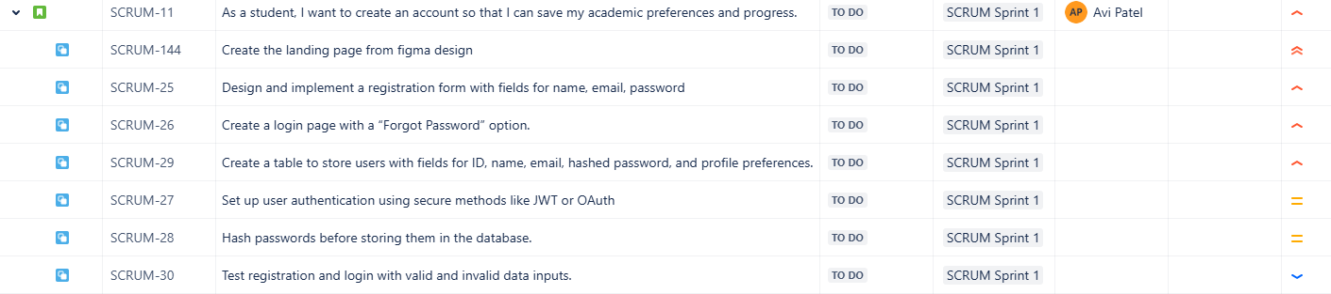

Task:

Design the landing page, theme, logo

Pull github stuff to download required packages

Send design files under tasks by deadline

Deadline: Thursday @11:59pm

Meet back: Friday at 5:30 pm decide on one, and start developing